GRANTWOOD PLAN

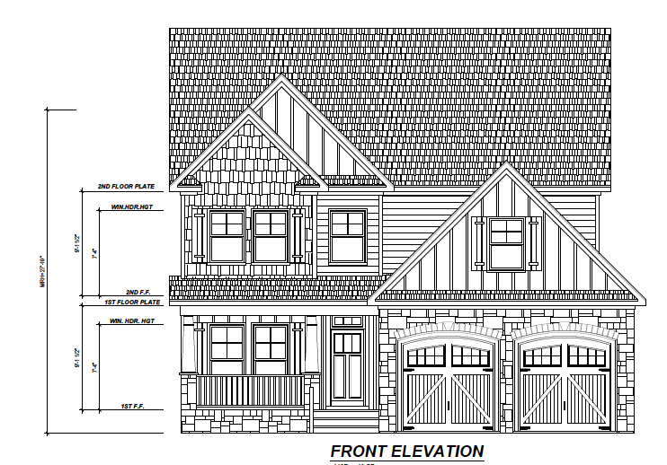

1ST FLOOR LAYOUT
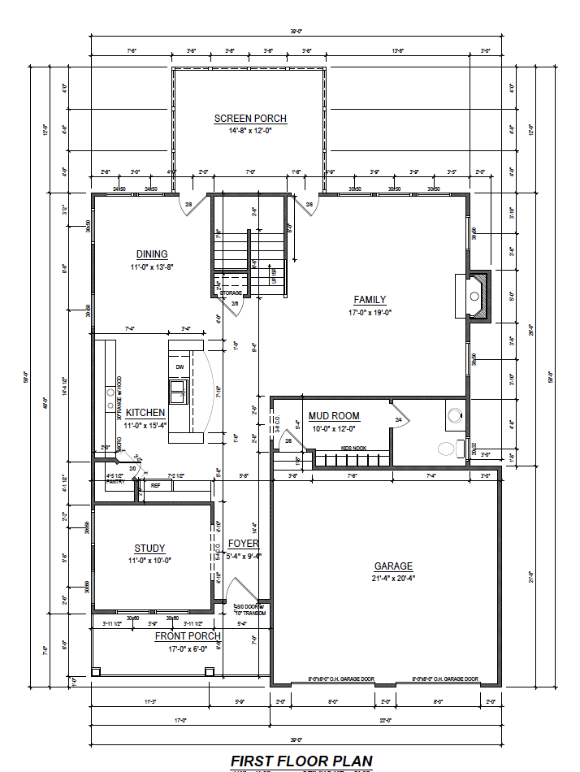
2ND FLOOR LAYOUT

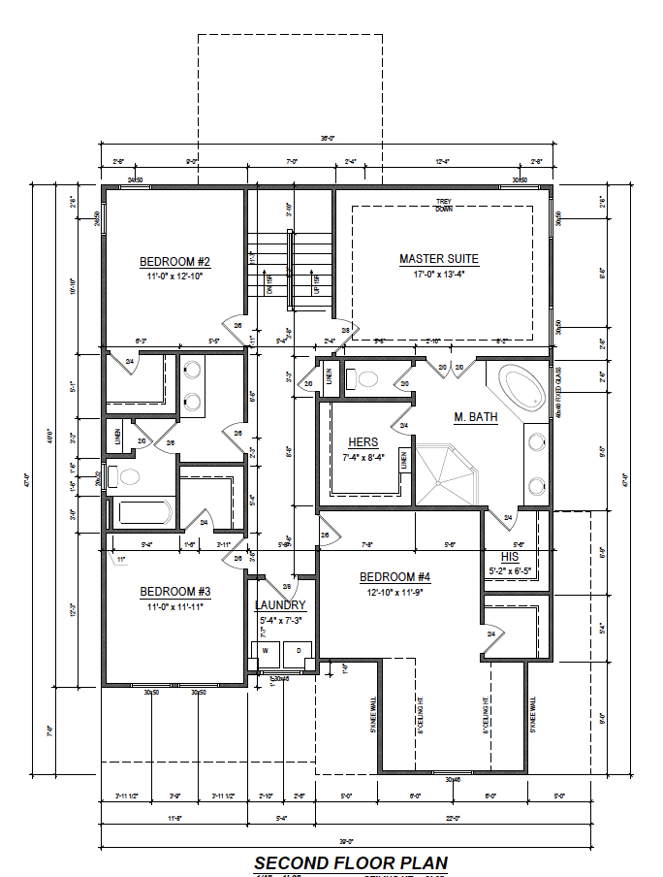
3RD FLOOR LAYOUT
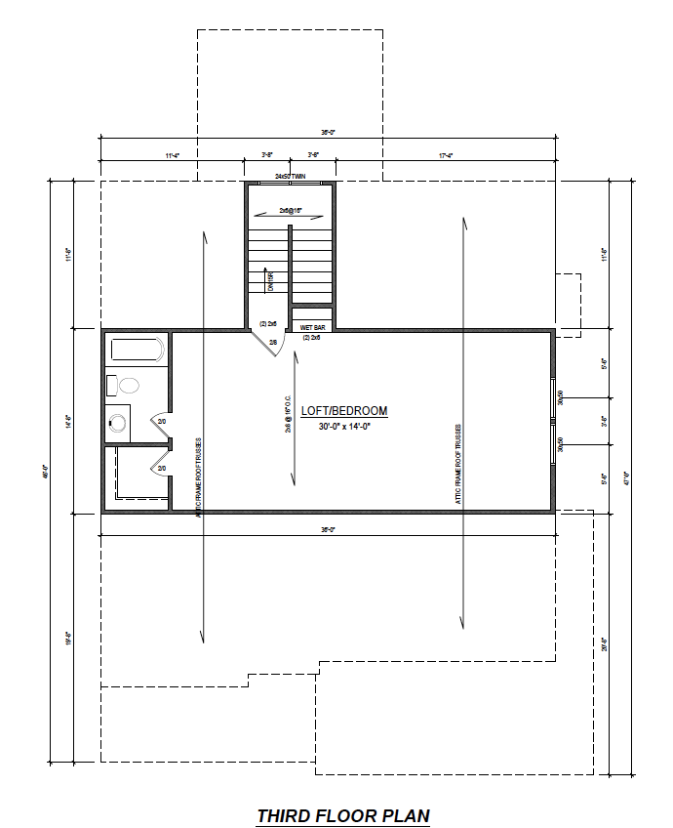

Heated Square Footage: 2,613
Unfinished Square Footage: 528 (Opt. 3rd floor WITH Bathroom)

